Detailed Design Document

______________________________________

**Product: Stop Payment**

**Publish Date: 06/09/2017**



**MUFG Union Bank, N.A.**

A member of MUFG, a global financial group

*Table of contents*

1. Design Details 1

1.1. Stop Payments 1

2. Service Interfaces 7

3. Business Rules and Use-Case Mapping 8

# Design Details

### Stop Payments

#### **Stop Payments – Check Inquiry**

##### **UI-Interaction**

The below diagram represents the UI interaction for the Stop Payment – Check inquiry page. It shows the different entry points to this UI, various UI components and the different interactions b/w these components.

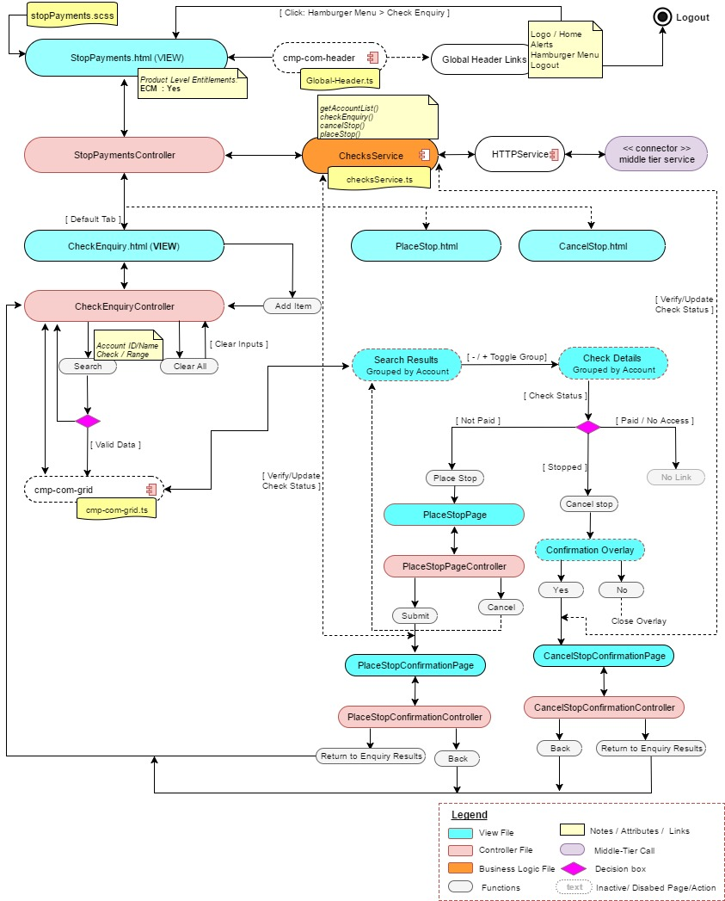

##### **Middle-tier interaction (sequence diagram)**

The below diagram represents the getAccountList(), checkEnquiry(), cancelStop() and placeStop() call from the UI to the backend services. Details of the service definition is available from the below link.



Refer the Service interface section for service level details

#### **StopPayments – Place Stop**

##### **UI-Interaction**

The below diagram represents the UI interaction for the Stop Payment – Place Stop page. It shows the different entry points to this UI, various UI components and the different interactions b/w these components.

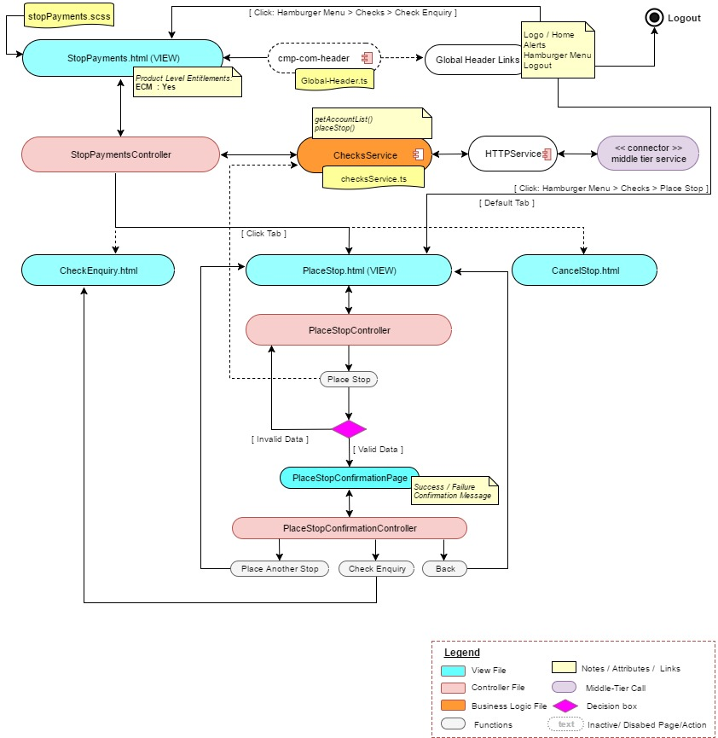

##### **Middle-Tier Interaction (sequence diagram)**

The below diagram represents the getAccountList() and placeStop() call from the UI to the backend services. Details of the service definition is available from the below link.



Refer the Service interface section for service level details

#### **Stop Payments – Cancel Stop**

##### **UI-Interaction**

The below diagram represents the UI interaction for the Stop Payment – Cancel Stop page. It shows the different entry points to this UI, various UI components and the different interactions b/w these components.

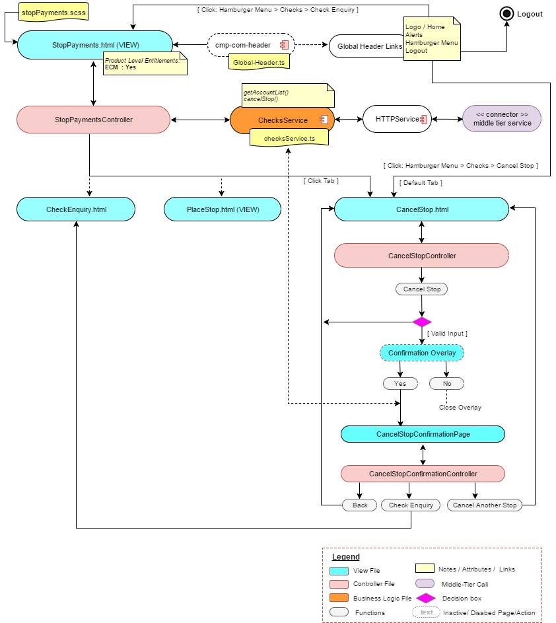

##### **Middle-Tier Interaction (sequence diagram)**

The below diagram represents the getAccountList() and cancelStop() call from the UI to the backend services. Details of the service definition is available from the below link.

Refer the Service interface section for service level details

# Service Interfaces

The service information is captured in the attached excel sheet. Refer the attached excel sheet for all the service related information’s. The sheet includes service interfaces that will be developed as new service API from the middle-tier. Along with the backend service details.



# Business Rules and Use-Case Mapping

The following link provides the business rule mapping with the use case from the functional spec document.

